TASKS:
- Draw the conceptual model.
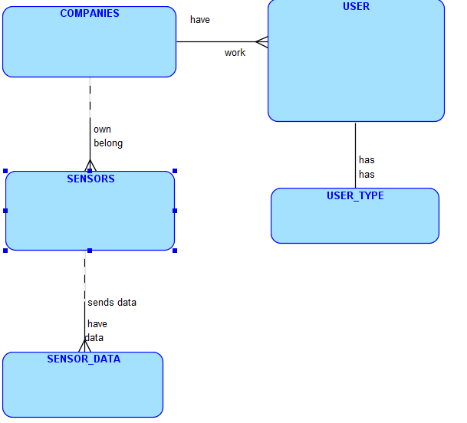
2. Identify the possible Entities, their Attributes and the relationships
between the entities from the given scenario.
COMPANIES
company_ID
name
address

SENSORS
sensor_id
company_id
sensor_name

USER
ID
Password
company_ID
first_name
last_name
job_ID
email_address

USER_TYPE
job_ID
description

SENSOR_DATA
data_ID
sensor_id
data-description
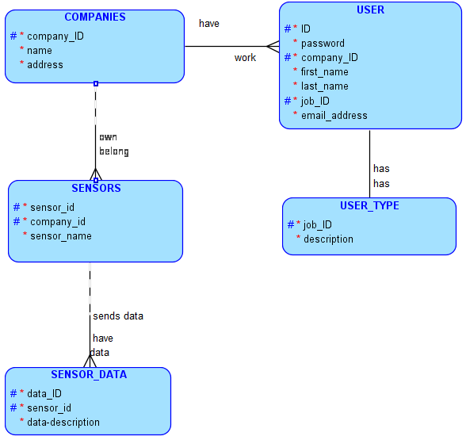

3. Construct your ERD following diagramming convention.
4. Draw the physical model
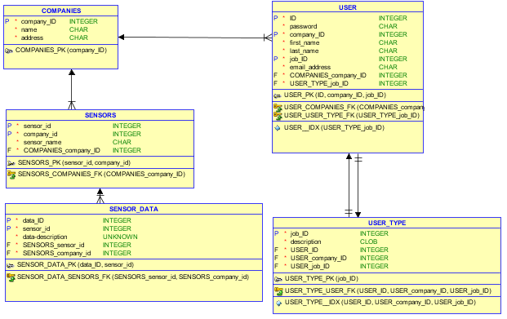
5. Write the sentences for each relationship, in both directions.
Each COMPANIES must have one or more USER. Each USER must work for one and only one COMPANIES.
Each COMPANIES may own one or more SENSORS. Each SENSORS must belong to one and only one COMPANIES.
Each SENSORS may send data to one or more SENSOR_DATA. Each SENSOR_DATA must have data from one and only one SENSORS.
Each USER must have one and only one USER_TYPE. Each USER_TYPE must have one and only one USER.

6. Map the relationships
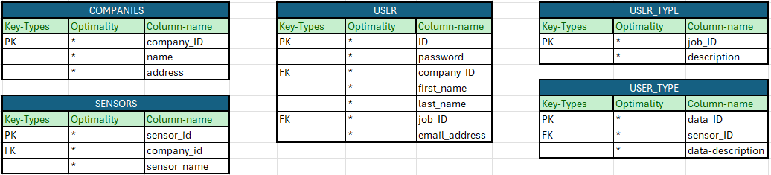
7. Draw the matrix diagram
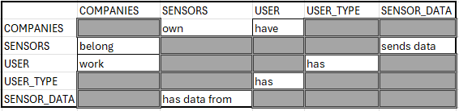

8. Using Apex, create the table for each entity and insert more than 3
rows in each table

